
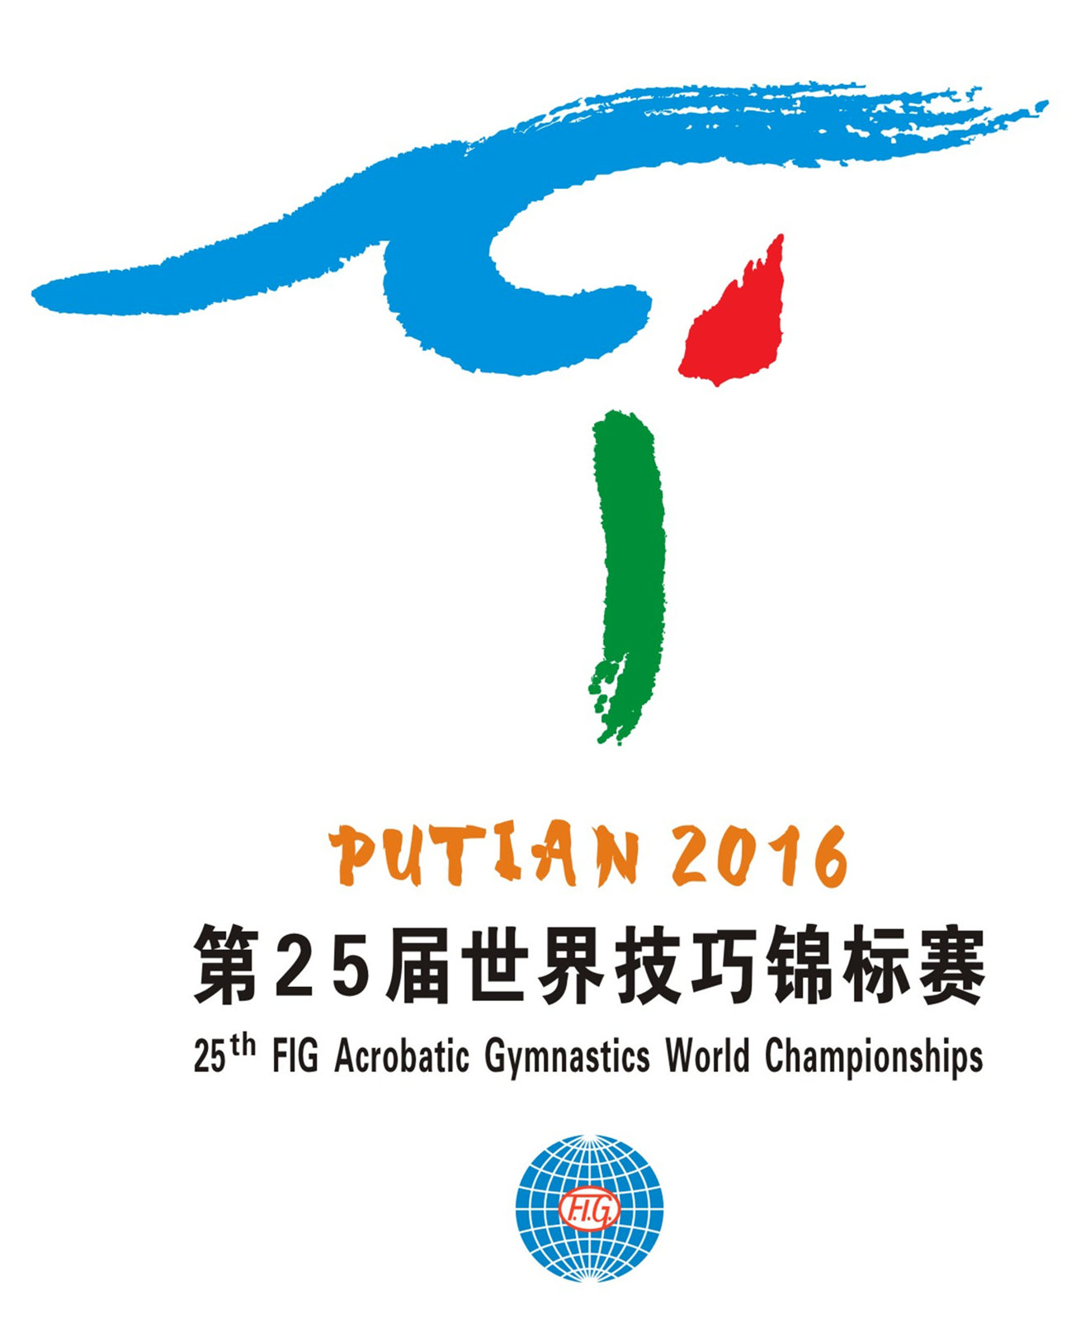
25th FIG Acrobatic Gymnastics World Championships
Putian, Fujian, CHN / April 1-3, 2016

Form to be sent to:
Organizing Committee
Fax: + 86 594 2386293 or E-mail: acrowch2016@189.cn

Deadline: January 6, 2016
form 4 - VISA REQUEST

Federation |  | Contact person:
Federation |  | Phone:
Federation |  | E-mail:

LAST NAME,  First name | Function | Gender  M/F | Date of birth  dd.mm.yyyy | Citizenship and  passport N° | Passport expiry date | Arrival date | Departure date | City*
* city where the visa application support letter must be sent to
Place and date | Seal of the NF | NF authorised signature
 |  | Signature of the President or Secretary General of the FIG affiliated NF

